**Step 1: Navigate to the Resource (Subscription or Resource Group)**

1. **Login to Azure Portal**: Go to the [Azure Portal](https://portal.azure.com).
2. Select the **Subscription** or **Resource Group** where the virtual machines are located.
3. In the left-hand menu, click on **Access control (IAM)**.

**Step 2: Create a Custom Role**

1. In the **Access control (IAM)** blade:
   * Click **+ Add** and choose **Add custom role** from the dropdown.
2. **Basics**:
   * **Name**: Enter a name, **“view access"**.
   * **Description**: Write a short description (e.g., "Role that allows viewing, starting, and stopping VMs only").
   * **Role Type**: Select **Custom role**.
   * Click **Next** to proceed.

**Step 3: Add Permissions**

1. In the **Permissions** tab:
   * Click **+ Add permissions**.
   * A search bar will appear for adding permissions to the role.
2. **Search for Permissions**:
   * **Provider**: Search for **Microsoft.Compute** and add the following permissions:
     + **Microsoft.Compute/virtualMachines/read** (for viewing VMs).
     + **Microsoft.Compute/virtualMachines/start/action** (for starting VMs).
     + **Microsoft.Compute/virtualMachines/deallocate/action** (for stopping VMs).
3. After adding the required permissions, click **Next**.

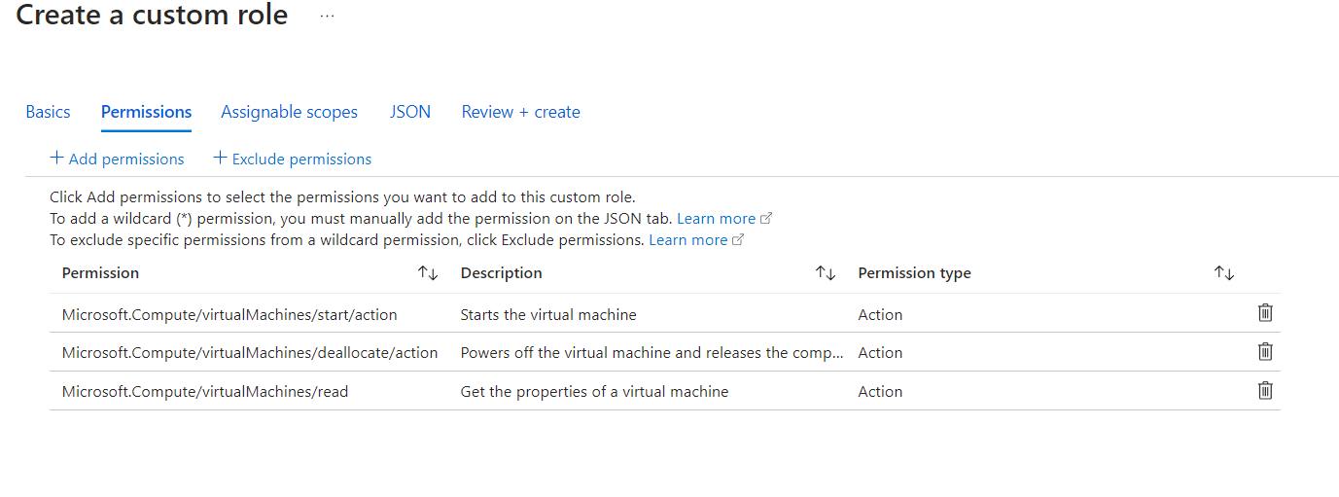

**Step 4: Assignable Scopes**

1. In the **Assignable scopes** tab:
   * Click **+ Add assignable scope**.
   * Click **Next**.

**Step 5: Review and Create the Custom Role**

1. Review the details you’ve configured for the custom role.
2. If everything looks correct, click **Create**.

